Institute on Lake Superior Geology
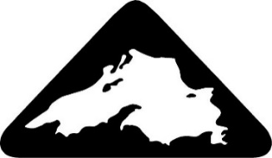

2024 Eisenbrey Student Travel Award Application

Date:

Student Name:

Contact Address and Phone:

Email:
Educational status:
Are you the senior author of an oral presentation or poster? Yes No
Will any other students be traveling with you? Yes No
If yes, then who?

Statement of Need (use additional page if necessary):

Applicant Signature:

Department Head Signature to Certify Student Status Only (an email from the supervisor is also acceptable):
SCAN or TAKE a readable picture
AND
EMAIL TO tjb@mtu.edu (Ted Bornhorst) by April 23, 2023

